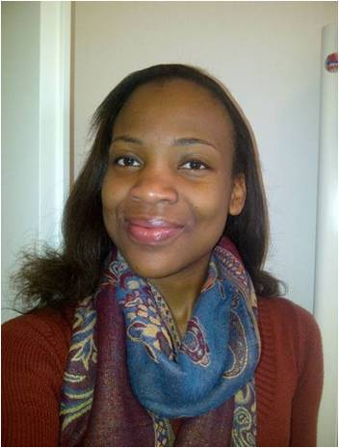Chimdindu Onwudiegwu is a Nigerian who is currently a Masters student at SAIS, Johns Hopkins University. I have been in DC since August 2012 and have enjoyed getting to know the city especially the free museums! My Master’s degree is in international development and economics. I intend to engage in development projects especially projects that develop and build the human capital base in Africa.  ISH has been a great place to live, it is like a melting pot. It has been a truly new and fresh experience to live under the same roof with people who have diverse perspectives on issues. It has been a learning experience on different levels- culture, food, international affairs, accents! More than the experience, it is the lessons I have learnt that stands out. One of such lessons is that there are various ways to deal with an issue but most times our perspective is colored by our background and previous experiences. The best solutions come when we widen our horizons and have diverse experiences-ISH does this in a natural way.

The scholarship program has made my time in DC and at ISH even more worthwhile. Rent in DC is expensive especially for a student and to have that burden lifted off is indescribable. Beyond the financial burden lifted off, the scholarship has also lifted the psychological burden off which has made me enjoy my time in DC more.