
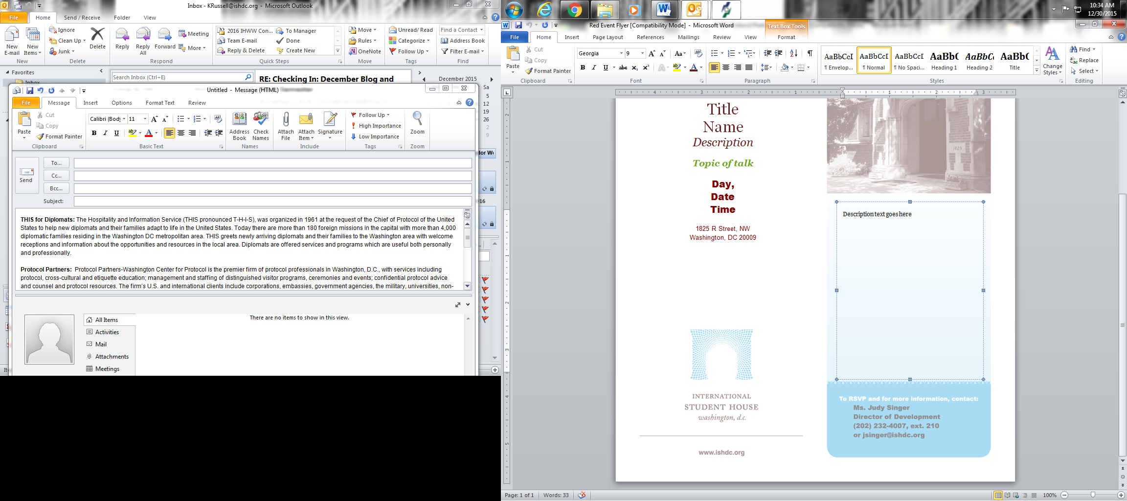

International Student House is pleased to invite you to a
Special program in partnership with

Gallup

What the Whole World is Thinking

In every corner of the Earth, the Gallup World Poll tracks the opinions that matter most. Using data available nowhere else, Gallup can analyze over 100 crucial world issues affecting people's lives -- issues such as the global economic meltdown, the Arab Spring, the earthquake in Haiti, good jobs and bad jobs worldwide, confidence in institutions, and societal instability. The World Poll is based on a framework called the Gallup Macroeconomic Path, a leadership model for successful societies.

Join this special program at Gallup HQ as their team shares about their excellent work on the World Poll and how you can utilize their work and this tool.

Friday, October 28, 2:00pm
Gallup, 901 F St NW

To RSVP and for more information, please contact:

Katie Russell
Development and Communications Associate
202.232.4007 ext. 211
krussell@ishdc.org
To RSVP and for more information, please contact:

Katie Russell
Development and Communications Associate
202.232.4007 ext. 211
krussell@ishdc.org

